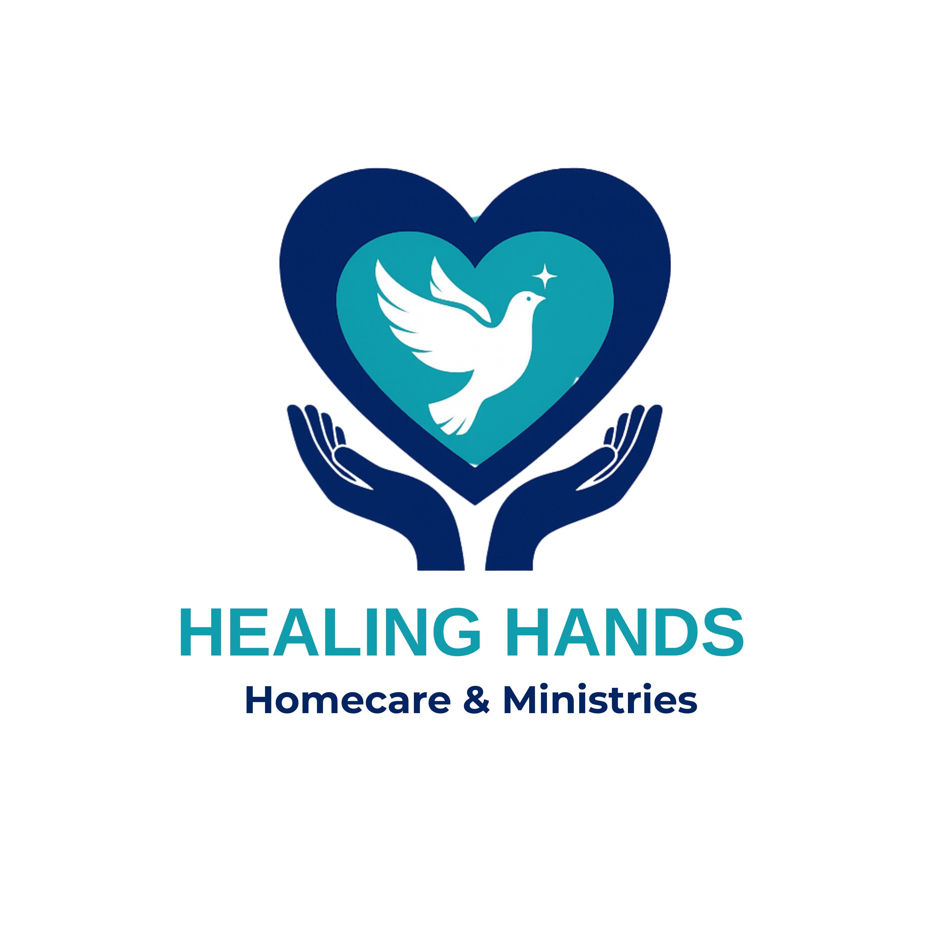
Healing Hands Homecare & Ministries
Client Welcome Packet
Compassionate Care in the Comfort of Your Home
Owner & Founder: Vanessa Castro
A Personal Welcome From the Founder
Dear Client and Family,
Welcome to Healing Hands Homecare & Ministries.
It is truly an honor to be entrusted with the care of you or your loved one. Healing Hands was created from a deep passion within my heart to serve others with compassion, dignity, and genuine love. As a nurse and caregiver, I have always believed that caring for people is not simply a profession — it is a calling.
Our mission at Healing Hands Homecare & Ministries is to provide compassionate, high-quality care that supports the physical, emotional, and spiritual well-being of every individual we serve, allowing them to live safely, comfortably, and with dignity in their own home.
Every client we serve becomes part of our extended family, and it is our privilege to walk alongside you in your journey of care.
Blessings,
Vanessa Castro
Owner & Founder
The Heart Behind Healing Hands
Healing Hands Homecare & Ministries was founded from a calling to care for others with compassion, excellence, and faith.
As a nurse, Vanessa Castro witnessed firsthand how meaningful, compassionate care can transform lives. Through years of serving patients and families, she developed a deep passion for helping individuals maintain dignity, comfort, and independence in their own homes.
Healing Hands was created to provide more than just care — it was built to offer hope, encouragement, and genuine connection. Healing Hands Homecare & Ministries is not simply a business; it is a ministry of service rooted in compassion and the desire to uplift others.
About Healing Hands Homecare & Ministries
Healing Hands Homecare & Ministries provides care with tender, loving hands that touch lives and heal hearts—just the way you deserve.
We believe in a holistic approach to healing, where compassion, dignity, and genuine connection are at the center of everything we do. To us, caregiving is more than a service; it is a calling and a work of the heart.
We uphold the highest standards of care by building meaningful relationships and lasting bonds within the communities we serve. Our dedicated staff is guided by strong core values and a commitment to ensuring every individual receives the personalized care they want and deserve.
At Healing Hands, we take pride in nurturing the mind, body, and spirit, providing a truly holistic healing experience.
Our Mission Statement
Our mission is to serve individuals and families with compassionate, dependable, and personalized home care while nurturing the mind, body, and spirit through dignity, respect, and heartfelt service.
“Do everything in love.” – 1 Corinthians 16:14
Our Core Values
Dignity and Respect
We believe every person deserves to be treated with honor and respect.
Patience and Faithfulness
We remain committed to dependable and consistent care.
Joy and Peace
We strive to bring comfort and positivity.
Kindness and Goodness
We serve others with genuine kindness and humility.
Gentleness and Excellence
We provide care with a gentle touch and commitment to quality.
Our Ministry Foundation
“But the fruit of the Spirit is love, joy, peace, forbearance, kindness, goodness, faithfulness, gentleness and self-control.” – Galatians 5:22-23
“Serve one another humbly in love.” – Galatians 5:13
“Whatever you do, work at it with all your heart, as working for the Lord.” – Colossians 3:23
“Each of you should use whatever gift you have received to serve others.” – 1 Peter 4:10
The Healing Hands Caregiver Promise
We promise to treat every client with dignity, respect, and compassion.
We promise to listen with patience.
We promise to provide dependable care.
We promise to create a peaceful environment.
We promise to approach care with kindness and gentleness.
We promise to honor the trust placed in us.
Services We Provide
Companion Care, Personal Care Aides, and Certified Nurse Aides
• Personal care (bathing, grooming, dressing)
• Mobility and transfer assistance
• Meal preparation
• Medication reminders (non-clinical)
• Transportation to appointments
• Light housekeeping
Skilled Nursing Services (Coming Soon)
Healing Hands Homecare & Ministries plans to expand services to include skilled nursing care in the future. These services are not currently provided at this time.
Future services may include:
• Medication administration
• Wound care
• Tube feedings
• Trach care and more
Spiritual Services
• Bible studies in home for spiritual growth
• Spiritual healing and prayer
• Spiritual guidance and counseling and more
Companion Care, Personal Care Aides, Certified Nurse Aides, Nursing Services, and Spiritual Support Services.
Client Rights
To be treated with dignity and respect
To receive safe care
To have privacy respected
To participate in decisions
To voice concerns
To refuse services
Client Responsibilities
Provide accurate health information
Maintain a safe environment
Treat caregivers respectfully
Communicate scheduling changes
Financial Policy
Payment is required per service agreement. Accepted methods include private pay and insurance.
Emergency Procedures
Call 911 immediately
Notify Healing Hands Homecare & Ministries
Follow emergency instructions
Client Information Form
Client Name: ____________________
DOB: ____________________
Address: ____________________
Phone: ____________________
HIPAA Acknowledgment
Signature: ____________________ Date: ____________________
Acknowledgment of Receipt
Signature: ____________________ Date: ____________________

